DATA
1) Aircraft: B17G Flying Fortress
2) Airfoil type: NACA 0018 (type that in the search feature of airfoil tool...it is also named naca0018-il)
3) Wing span: 104 feet
4) Average Chord: 13 feet 6 inches (13.5 feet)
5) MTOW: 65,500 lbs

Exercise 4: Drag and Applications

The first part of this week’s assignment is to revisit our reciprocating engine powered (i.e. propeller type) aircraft from last week.

1. Selected Aircraft (from last week’s module):

Make sure to review your data and results from last week and any feedback that you may have received on your work, in order to prevent continuing with faulty data.

2. Main Wing Airfoil type & on-line database designator (from last week’s module):

3. Aircraft Maximum Gross Weight [lbs] (from last week’s module):

4. Wing Span [ft] (from last week’s module):

5. Average Chord Length [ft] (from last week’s module):

6. Wing Area ‘S’ [ft²] (from last week’s module):

7. Find the Aspect Ratio ‘AR’ for your selected aircraft wing. (Use the wing span and average chord length from last week’s module/from above. See also page 63 in your textbook.):

8. C_{Lmax} for your airfoil (from last week’s module):

9. Standard sea level Stall Speed ‘V_{s}’ for your aircraft [kts] (from last week’s calculation):

Find the appropriate drag polar curve for your airfoil selection (2. above; from last week’s module). You can utilize any officially published airfoil diagram for your selected airfoil or use again the Airfoil Tool at http://airfoiltools.com/search .

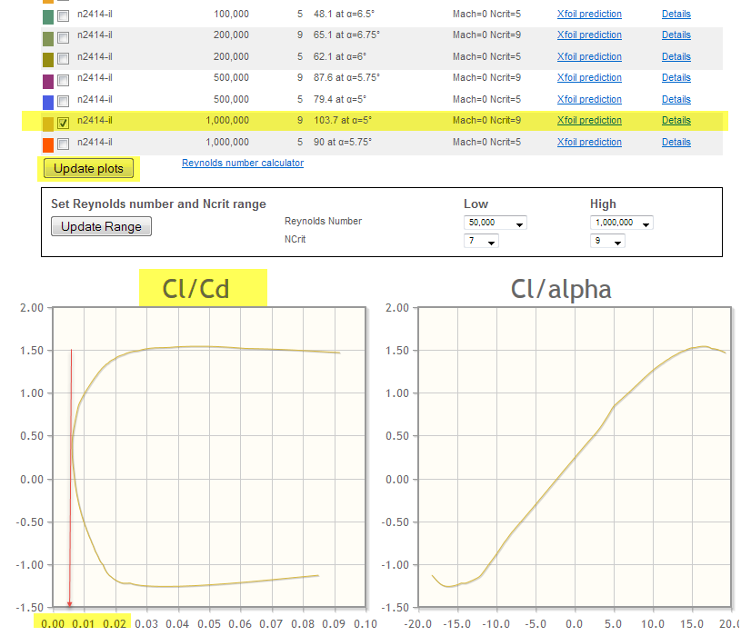
Concentrate for this exercise on the Cl/Cd (coefficient of lift vs coefficient of drag) plot, i.e. the so called drag polar. Use again only the curve for the highest Reynolds-number (R_{e)} selected (i.e. remove all checkmarks, except the second to last, and press the “Update plots” tab).

How to find the minimum Cd

10. From the polar plot, find the C_{Dmin} value for your airfoil, i.e. the lowest value that the coefficient of drag ‘Cd’ (bottom scale in the online tool depiction) reaches. (Tip: for a numerical breakdown of the plotted curve, you can again select the “Details” link and directly read the lowest C_{D} value in the table – third column, labeled “CD”):

What we’ve just found (…with some degree of simplification…) is the parasite drag coefficient for our airfoil, i.e. the drag that exists due to skin friction and the shape of our airfoil, even when little or no lift is produced. However, this value will only represent the airfoil, i.e. main wing portion of our aircraft; therefore, let us for the remainder of our calculations assume that our aircraft is a Flying Wing type design and the total C_{DP} for the aircraft is the same as the C_{Dmin} that we’ve just found.

Let us also assume that we are at standard sea level atmospheric conditions and that our wing has an efficiency factor of e = 0.82.

A. Prepare and complete the following table for your aircraft (with the data from 1. through 8. above). Start your first row with the Stall Speed ‘V_{s}’ (from 7. above) and start the second row from the top with the next higher full twenty knots above that stall speed. Then increase speed with every subsequent row by another 20 knots until reaching 300 kts. You are again encouraged to utilize MS® Excel as shown in the tutorial video and can also increase your table detail. However, the below depicted, and above described, interval is the minimum required for this assignment.

V  (KTAS) | q  (psf) | C_{L} | C_{DP} | C_{DI} | C_{D} | C_{L} / C_{D} | D_{P}  (lb) | D_{I}  (lb) | D_{T}  (lb)
V_{S}
60
80
100
120
140
160
180
200
220
240
260
280
300

Equations for Table:

q = ${σ V_{k}^{2}}/{295}$ C_{L} = C_{Di} =[1/ (πeAR)] C_{L} ²
C_{D} = C_{DP} + C_{Di} C_{D} = C_{DP} + [1/ (e AR)] C_{L} ² Dp = C_{Dp} q S
Di = C_{Di} q S = [1/ (e AR)] C_{L}² q S Dt = Di + Dp = C_{D} q S

Answer the following questions from your table.

I) Determine the minimum total drag ‘D_{min}’ [lbs] (i.e. the minimum value in the total drag ‘D_{T}’ column):

II) Determine the airspeed at which this minimum drag occurs ‘V_{Dmin}’ [kts] (i.e. the speed associated with the row in which ‘D_{min}’ was found):

III) Compare parasitic ‘D_{P}’ and induced ‘D_{I}’ drag at V_{Dmin}. What is special about this point in your table?

IV) Determine the maximum C_{L}/C_{D} value in your table (i.e. the maximum value in the C_{L}/C_{D} column) and the speed at which it occurs.

V) Compare your results in IV) with II) and comment on your findings.

VI) Explain which values in your table will directly allow glide performance prediction and how (Tip: Reference again the textbook discussion pp. 61-63).

B. If the gross weight of your aircraft is decreased by 10% (e.g. due to fuel burn), how would the stall speed change? Support you answer with calculation as well as written assessment. (Remember, stall speed references and discussions can be found pp. 43-45 in your textbook.)

For the second part of this assignment use the given figure below (Figure 1.13 from Aerodynamics for Naval Aviators [1965]) to answer the following questions. (This assignment is designed to review some of the diagram reading skills required for your midterm exam; therefore, please make sure to fully understand all the diagram information and review book, lecture, and/or tutorials if necessary.):

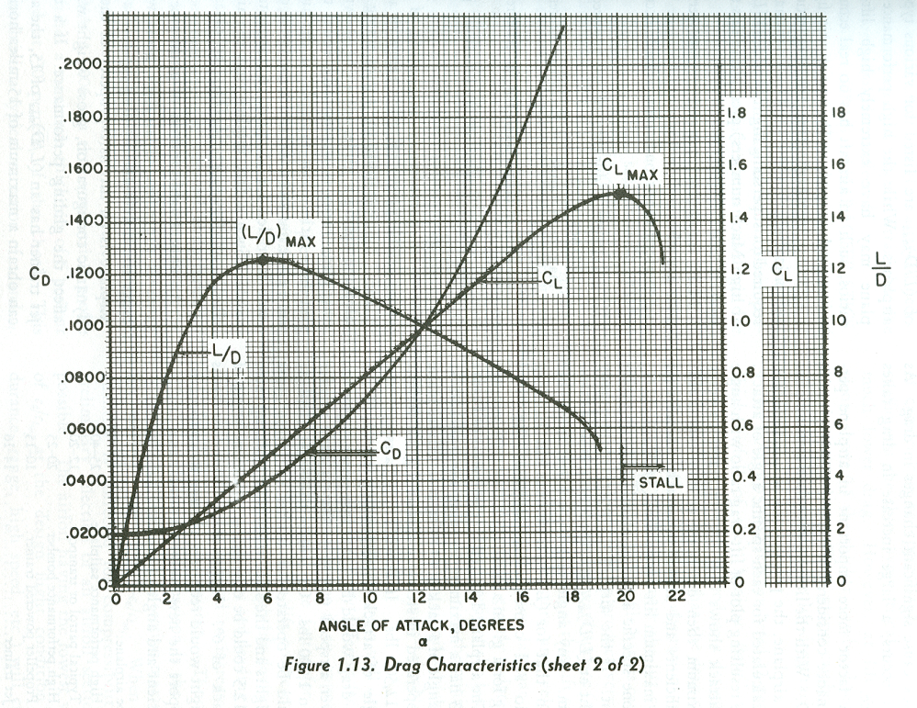
Figure 1.13 from Aerodynamics for Naval Aviators (1965).
C. What is the Angle of Attack at Stall for the aircraft in Figure 1.13?

D. What Angle of Attack is associated with Best L/D?

E. What would be the best Glide Ratio for this aircraft?

F. What is the maximum coefficient of lift (C_{Lmax}) value?

Exercise 5: Aircraft Performance

For this week’s assignment you will revisit your data from previous exercises, therefore please make sure to review your results from the last modules and any feedback that you may have received on your work, in order to prevent continuing with faulty data.

1. Selected Aircraft (from module 3 & 4):

2. Aircraft Maximum Gross Weight [lbs] (from module 3 & 4):

Jet Performance

In this first part we will utilize the drag table that you prepared in module 4.
Notice that the total drag column, if plotted against the associated speeds, will give you a drag curve in quite similar way to the example curves (e.g. Fig 5.15) in the textbook. (Please go ahead and draw/sketch your curve in a coordinate system or use the Excel diagram functions to depict your curve, if so desired for your own visualization and/or understanding of your further work.)
Notice also that this total drag curve directly depicts the thrust required when it comes to performance considerations; i.e. as discussed on pp. 81 through 83, in equilibrium flight, thrust has to equal drag, and therefore, the thrust required at any given speed is equal to the total drag of the airplane at that speed.

Last but not least, notice also that, so far, in our analysis and derivation of the drag table in module 4, we haven’t at all considered what type of powerplant will be driving our aircraft. For all practical purposes, we could use any propulsion system we wanted and still would come up with the same fundamental drag curve, because it is only based on the design and shape of the aircraft wings.

Therefore, let’s assume that we were to power our previously modeled aircraft with a jet engine.

A. What thrust [lbs] would this engine have to develop in order to reach 260kts in level flight at sea level standard conditions? Notice again that in equilibrium flight (i.e. straight and level, un-accelerated) thrust has to be equal to total drag, so look for the total drag at 260kts in your module 4 table. (In essence, this example is a reverse of the maximum speed question – expressing it graphically within the diagram: We know the speed on the X-axis and have the thrust required curve; that gives us the intercept point on the curve through which the horizontal/constant thrust available line must go.)

B. Given the available engine thrust from A. above, what is the Climb Angle [deg] at 200kts and Maximum Gross Weight? (Notice that climb angle directly depends on the available excess thrust, i.e. the difference between the available thrust in A. above and the required thrust from your drag curve/table at 200kts. Then, use textbook Eq. 6.5b relationships to calculate climb angle).

C. What is the Max Endurance Airspeed [kts] for your aircraft? Explain how you derived at your answer.

Prop Performance

In this second part we will utilize the same aircraft frame (i,e, the same drag table/graph), but this time we will fit it (more appropriately and closer to its real world origins) with a reciprocating engine and propeller.

D. To your existing drag table, add an additional column (Note: only the speed column, the total drag column and this third new column will be required – see below). To calculate the Power Required in the new column, use textbook p. 115 equation and the V and D values that you already have: P_{r} = D*V_{k} / 325
V
P_{r}
maxR
maxE
V  (KTAS) | D_{T} = T_{r}  (lb) | P_{r}  (HP)
V_{S}
80
100
120
140
160
180
190
200
220
240
260

E. Draw/sketch (or plot in an Excel diagram) your Power Required curve against the speed scale from the table data in A. above. (Note: This step is again solely for your visualization and to give you the chance to graphically solve the next questions in analogy to the textbook and examples. See sketch above.)

F. Find the Max Range Airspeed [kts] for your aircraft. Remember from the textbook discussion pp. 125 through 127 that Maximum Range Airspeed for a reciprocating/propeller driven aircraft occurs where a line through the origin is tangent to the power required curve (see textbook Fig. 8.9 and sketch above). However, as per the textbook discussion, it is also the (L/D)_{max} point, which we know from our previous work on drag happens where total drag is at a minimum (therefore, you can also reference the total drag column in your table and find the airspeed associated with the minimum total drag value).

G. Find the Max Endurance Airspeed [kts] in a similar fashion. (Tip: The minimum point in the curve will also be visible as minimum value in the P_{r} column of your table.)
H. Let’s assume that the aircraft weight is reduced by 10% due to fuel burn (i.e. similar to the gross weight reduction in Exercise 4, problem B).

I) Aircraft Weight [lbs] for 90% of Maximum Gross Weight (i.e. the 10% reduced weight from above). Simply apply the factor 0.9 to your aircraft Maximum Gross Weight from number 2. above:

II) Find the new Max Range Airspeed [kts] for the reduced weight. Remember (from your textbook reading and Exercise 4, B.) that the weight change influence on speed was expressed by Eq. 4.2 in the textbook.

Landing Performance

For this last part of this week’s assignment you will continue with your reciprocating engine (i.e. prop) powered aircraft and its reduced weight. Let’s first collect some of the data that we already know:

3. Stall Speed for 90% of Maximum Gross Weight (i.e. the stall speed for 10% decreased weight from above, which we already calculated in Exercise 4, problem B.):

I. Find the Approach Speed [kts] for your 90% max gross weight aircraft trying to land at a standard sea level airport. Approach speed is usually some safety margin above stall speed -.let’s assume for our case a factor of 1.2, i.e. multiply your stall speed from number 3. with a factor of 1.2 to find the approach speed:

J. Determine the drag [lbs] on the aircraft during landing roll.

I) For simplification, start by using the total drag value [lbs] for stall speed (for the full weight aircraft) from your module 4 table:

II) Adjust the total drag (from I) above) for the new weight (from H. I) above) by using the textbook Equation 7.1 relationship: D₂/D₁ = W₂/W₁

III) Find the average drag [lbs] on the aircraft during landing roll. A commonly used simplification for the dynamics at play is to use 70% of the total drag at touchdown as the average value. Therefore, find 70% of your II) result above.

K. Find the frictional forces during landing roll. The Total Friction is comprised of Braking Friction at the main wheels and Rolling Friction at the nose/tail wheel. For this example, let’s assume that, in average, there is 75% of aircraft weight on the main wheels and 25% on the nose/tail wheel over the course of the landing roll. The Average Friction Force is then the product of respective friction coefficient and effective weight at the wheel/wheels (see p. 209 textbook):
F = *N

I) If the rolling friction coefficient is 0.02, what is the Rolling Friction [lbs] on the nose/tail wheel? (Remember that only 25% of total weight are on that wheel and that the weight was reduced by 10% from maximum gross weight – see H I)):

II) If the main wheel brakes are applied for an optimum 10% wheel slippage (as discussed on textbook pp. 209/210), what is the Braking Friction [lbs] on the main wheels during landing roll on a dry concrete runway? Use textbook figure 13.9 to determine the friction coefficient. (Remember that the weight on the main wheels is only 75% of total aircraft weight).

III) Find the total Average Friction [lbs] during landing by building the sum of I) and II):

L. Find the Average Deceleration [ft/s²] during landing roll. Use the same rectilinear relationships as in module 1, applying the decelerating forces of friction and drag from J. III) & K. III) above. Assume that residual thrust is zero. (Keep again in mind that for application of Newton’s second law, mass is not the same as weight. Your result should be a negative acceleration value since the aircraft decelerates in this case.):

M. Find the Landing Distance [ft] (Remember that we start from a V0 at approach speed and want to slow the aircraft to a complete stop, applying the negative acceleration that we found in L. Also, remember to convert approach speed from I. above into a consistent unit of ft/s.):

N. If your aircraft was to land at a higher than sea level airport (e.g. at Aspen, Co) what factors would change and how would it affect your previous calculations, especially your landing distance. Explain principles and relationships at work and support your answer with applicable formula/equations from the textbook. You can include example calculations to support your answer:

